Dr H.V Trivedi & Partners

Local Patient Participation Report 2011/12

Parker Drive Medical Centre
122 Parker Drive, Leicester. LE4 0JF
Tel: 0845 045 0388 Fax: 0116 2354816

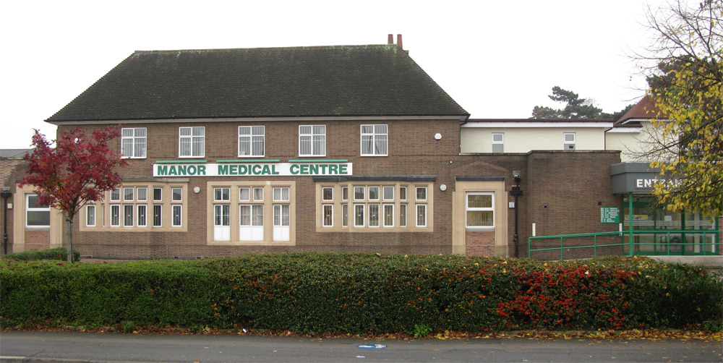
Manor Medical Centre
577 Melton Road, Thurmaston, Leicester. LE4 8EA
Tel: 0845 045 0562 Fax: 0116 2696980

Website: www.drtrivediandpartners.co.uk

Establishing Our Patient Group
We started to advertise to recruit members to establish our group in June 2011, we placed posters and leaflets within our waiting areas, advertised on the electronic display boards and on the practice website. Staff and doctors were also encouraging our patients to join.

Recruitment Process
Patients who were interested filled out an application form which included their name, Date of Birth, address and ethnicity status. We needed this information to gather statistics to make sure our group was representative of our practice population.

Disappointingly, the uptake was very low.

We held our first introductory meeting on the 11th August 2011, this was with the two practice managers, senior partner, partner and four patients out of the eight who had expressed an interest.

An agenda was formed.

Introductions were made to gain an insight into the patients background to see what they could bring to the group.

We discussed “What is a Patient Participation Group?” (PPG), the purpose of the group and the aim and objectives.

We focused on how we could attract more members to the group which was representative of our practice population.

The patients offered to go out into the wider community and display more of our posters advertising the group within local schools, churches, community centres, pharmacies, libraries, post offices, local shops and to also spread the word through word of mouth.

We placed an advertisement in the local Thurmaston Times, unfortunately there was nothing available for the Beaumont Leys area.

We are still aiming to attract between 12-15 patients to the group. To date, we have had 13 patients who have expressed an interest to join but we only have between 6-8 regular attendees.

Practice Demographics
We are an inner city practice based over two sites with a practice population of approx 15,025 patients, split as follows:

0-16 Male = 1569 Female = 1511
17-35 Male = 2100 Female = 2102
36-64 Male = 2977 Female = 2746
65-74 Male = 494 Female = 517
75+ Male = 433 Female = 576

Parker Drive Medical Centre serves Beaumont Leys, Stocking Farm, Mowmacre Hill and the Stadium Estate, the majority of which are council housing. There is a higher than average unemployment rate and areas of high depravation. Parker Drive Medical Centre has mainly a Caucasian population.

Manor Medical Centre is not actually based in the inner city and is sited on the Thurmaston Village and Leicester Border, it covers a large cross section of the community, the housing is varied, there are two council estates in Thurmaston and a variety of private housing. Also served by this surgery is the Rushey Mead Estate which comprises of rented and private housing, Manor Medical Centre has a high indian/asian population.

Patient Group Representatives
Currently, our group is represented with 8 female and 5 male patients with age ranges from 39 – 76 years of age, there is a mix of English, British white, Indian and Hindu patients and both sites are equally represented.

We are struggling to attract the younger generation to our group, one member of the group has approached the school councils at seven of the local schools to attract some of the over 16’s but as yet no response.

Priority Issues
We discussed with the group that we needed to work on a practice survey and it was clear from discussions and questions raised at our subsequent meetings that the patients had some issues that could be addressed in this survey.

These were mainly around the appointment system and consultations.

Development of the Practice Survey
We brought some sample surveys along for the group to look at and they were very impressed with the GPAQ (General Practice Assessment Questionaire) which was the survey we had used previously.

The GPAQ survey is very thorough and addresses a lot of areas within general practice, the group felt this was excellent and wanted to base our own practice survey around this.

From here, we spent many hours amending the survey to suit our own practice.

We decided that we would run separate surveys for Parker Drive Medical Centre and Manor Medical Centre to see if patients had different views about the services we provide.

The final version of the survey was agreed by the group on 1st December 2011.
(A copy of which can be found on the practice website)

www.drtrivediandpartners.co.uk

How the Survey was Conducted
INTRODUCTION

This year the practice had designed its own practice survey in conjunction with our Patient Participation Group which was formed in August 2011.

The practice was responsible for analysing its own data and producing a report to publish the results of the survey on our practice website and also within our waiting rooms by end of March 2012.

The practice in conjunction with the PPG would reflect on the results and produce an action plan for any proposed changes.

AIMS

The aim of the survey was to gain the views from our registered patients on the services we provide and giving them the opportunity to make any comments/suggestions for future changes/developments.

The surveys were conducted within both of our surgeries and we aimed to obtain at least 300 completed questionnaires and 10 postal questionnaires per site. (Postal questionnaires were sent to patients who had not visited the surgery within last 6 months of different ages and ethnic groups and chosen at random from an audit run from our computer. (A stamped addressed envelope was enclosed for their reply)

The survey was conducted between 7th December 2011 and 23rd December 2011, both at Parker Drive Medical Centre and Manor Medical Centre. We targeted our registered patients who attended the surgery between our core hours of opening.

Posters explaining the survey to our patients were displayed in the waiting rooms and outside consulting rooms.

Reception staff were informed of the purpose of the survey, the criteria of who can take part and the procedure for inviting patients to take part.

OUTCOME

Staff worked extremely hard during the three week period to get as many surveys completed as possible.

There was a very good uptake rate to the survey completed in the surgery but a very low uptake rate on the postal questionnaire responses.

All completed useable surveys were analysed by the Practice Manager and Admin Clerk over a period of 2 weeks and the findings of the survey were compiled into a report separated by each surgery.

RESULTS

The results can be found on the practice website

www.drtrivediandpartners.co.uk

Review Meeting
A meeting with the Patient Group was arranged to give them the opportunity to review and discuss the survey results along with the practice managers and the doctors.

Firstly, we discussed the list of Positive points that patients had highlighted in the survey, the group were very impressed with the comments made and suggested we try and encourage patients to add their positive comments onto the NHS choices website at:

www.nhs.uk

We then worked through the Negative points and suggested areas for improvement that the patients had raised.

In summary these areas are as follows:

APPOINTMENT SYSTEM

Communication on how the appointment system works and how to obtain emergency appointments needs improving – need to advertise the system better so patients have an easier understanding and to also look into the possibility of translating it into some different languages.

Receptionists asking the patient what the problem is before giving an appointment – need to address this area as not always appropriate (unless in cases of emergency) suggested script to be devised so all calls are being handled the same way.

TELEPHONE SYSTEM

0845 number – concerns over the costs of calls from a mobile - practice to look into the technical issues with Leicestershire HIS telecoms as the contract lies with them.

Busy telephone system – suggestions of more lines to be put in
The telephone system has been upgraded to allow for a queuing system with two additional lines increasing from two to four. Unfortunately, due to the current financial climate and resources we have, we are unable to employ extra staff to be able to answer any more additional lines. In the interim, existing practice staff that are available will be on standby to answer the phones at peak times.

ACCESS TO A DOCTOR

Continuity of care – patients seeing different doctors instead of trying to see same doctor – difficulties arise with having two sites and high demand for appointments with the more popular doctors .
Doctors/staff to encourage patients to see the same doctor, doctors to re-book own appointments when the patient needs a follow-up.
Suggestions for more stability on GP rotas, ie: keeping GPs at same site on regular sessions and full days session rather than two half days at different sites

Consultations – too much focus on computer, rushed, no eye contact and lack of communication - Doctors all have their own pattern/style of working and need to review their consultation methods through a peer to peer review session.
.
More cultural mix of doctors – any future vacancies that arise, the practice may need to consider recruiting doctors who have varied language skills.
We have already addressed recruiting more female doctors into the practice with the successful recruitment of two new salaried female doctors in July and Oct 2011.

RECEPTION

Self checking-in screen – information on how to use to self checking screen should be available as some patients are experiencing problems using it. It will not check you in if you arrive more than 20 minutes early or 5 minutes late and they are advised to report to reception.
Larger screens are soon to be installed in the waiting areas.

Privacy and confidentiality – very difficult with an open reception
Manor Medical Centre has use of a patient interview room, which is located just off the waiting room for patients/staff to use if need to discuss anything private.
Parker Drive Medical Centre has a quiet area at the side of reception for patients/staff to use if need to discuss anything private.
Staff awareness of what is discussed and disclosed on reception, not to repeat patient’s details back when making appointments etc.

More seating space at Manor Medical Centre – The waiting area at Manor Medical Centre has recently been extended with new adequate seating.

Parker Drive needs to address their seating in the waiting area as it is ripped/slashed and needs recovering.

Magazine and leaflets in waiting room at Manor Medical Centre – There are mixed views around this due to the infection control guidance, it is advisable to refrain from having magazines in the waiting areas.

There is a possibility in the near future of TV screens being installed in the waiting rooms for viewing health promotion material and to be used as a tool for information sharing.

PRESCRIPTIONS

Ordering prescriptions on-line – practice to look into to see if currently available with our computer system and to look at the feasibility of introducing this facility in the near future.

Some points which were raised that specified a named individual in the practice will be discussed and addressed internally – the group were happy with this arrangement.

Areas Identified for Further Discussion with PCT / CCG
Appointment system
Requests for more flexibility to accommodate the employed i.e saturdays at Parker Drive, sundays and late evenings at both surgeries.

To discuss with the doctors and Primary CareTrust/Clinical Commissioning Group options available to the practice to accommodate any of these requests.

Widening of doorways
Issue raised by wheelchair users at Manor Medical Centre where by they had difficulty opening the door into the corridor and general access to the consulting rooms.

To be discussed with the Primary CareTrust/Clinical Commissioning Group ref DDA compliance and improvement grant funding and to liaise with the practice architect for any suitable solutions.

Parking problems – Parker Drive Medical Centre
There is absolutely no scope for improvement on this, due to the location of the surgery on a busy road and no spare land to extend, previous applications to the PCT have been turned down.

To open up dialogue again with the Primary CareTrust/Clinical Commissioning Group ref relocation and improvement grant funding.

Practice Action Plan
We gathered all the views and suggestions together and created an action plan which was approved by the practice and the group. (A copy can be found on the practice website)

www.drtrivediandpartners.co.uk

This will be regularly reviewed and updated on subsequent achievement of all areas identified for improvement.

