Dr S.M Arolker & Partners

Local Patient Participation Report 2014/15

Parker Drive Medical Centre
122 Parker Drive, Leicester. LE4 0JF
Tel: 0116 2353148 Fax: 0116 2354816

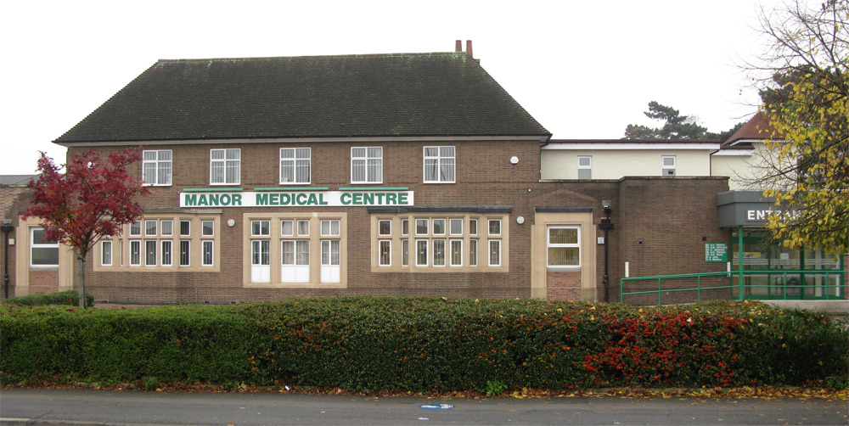
Manor Medical Centre
577 Melton Road, Thurmaston, Leicester. LE4 8EA
Tel: 0116 2696765 Fax: 0116 2696980

Website: www.drarolkerandpartners.co.uk

Establishing Our Patient Group
We started to advertise to recruit members to establish our group in June 2011, we placed posters and leaflets within our waiting areas, advertised on the electronic display boards and on the practice website. Staff and doctors were also encouraging our patients to join.

Recruitment Process
Patients who were interested filled out an application form which included their name, Date of Birth, address and ethnicity status. We needed this information to gather statistics to make sure our group was representative of our practice population.

Disappointingly, the uptake was very low.

We held our first introductory meeting on the 11th August 2011, this was with the two practice managers, senior partner, partner and four patients out of the eight who had expressed an interest.

An agenda was formed.

Introductions were made to gain an insight into the patients background to see what they could bring to the group.

We discussed “What is a Patient Participation Group?” (PPG), the purpose of the group and the aim and objectives.

We focused on how we could attract more members to the group which was representative of our practice population.

The patients offered to go out into the wider community and display more of our posters advertising the group within local schools, churches, community centres, pharmacies, libraries, post offices, local shops and to also spread the word through word of mouth.

We placed an advertisement in the local Thurmaston Times, unfortunately there was nothing available for the Beaumont Leys area.

We were aiming to attract between 12-15 patients to the group.

Practice Demographics
We are an inner city practice based over two sites with a practice population of approx 15,518 patients, split as follows:

0-16 Male = 1650 Female = 1590
17-35 Male = 2087 Female = 2133
36-64 Male = 3042 Female = 2868
65-74 Male = 557 Female = 602
75+ Male = 429 Female = 560

Parker Drive Medical Centre serves Beaumont Leys, Stocking Farm, Mowmacre Hill and the Stadium Estate, the majority of which are council housing. There is a higher than average unemployment rate and areas of high depravation. Parker Drive Medical Centre has mainly a Caucasian population.

Manor Medical Centre is not actually based in the inner city and is sited on the Thurmaston Village and Leicester Border, it covers a large cross section of the community, the housing is varied, there are two council estates in Thurmaston and a variety of private housing. Also served by this surgery is the Rushey Mead Estate which comprises of rented and private housing, Manor Medical Centre has a high indian/asian population.

Patient Group Representatives
Currently, our group is represented with 6 female and 7 male patients with age ranges from 60 – 76 years of age, there is a mix of English, British white, Indian and Hindu patients and both sites are equally represented.

We are struggling to attract the younger generation to our group, one member of the group has approached the school councils at seven of the local schools to attract some of the over 16’s but as yet no response.

We are looking to recruit some new members from our waiting list as we have just had a few members leave the group whilst still wanting to keep the group a manageable size. Patients are actively encouraged to send in any suggestions/comments to members of the existing group to bring forward to the meetings.

Priority Issues
This year we decided not to run an annual patient survey due to the Introduction of the Friends and Family Test. We are at present gathering patient feedback through patient comments/suggestions and the use of the F&F test which is available to complete on-line through our practice website and through post cards that patients can fill out in the surgery.

As this was only introduced into the practice from December 2014, we do not have much feedback at the moment to report on, but are actively trying to get patients to complete the test.

Three Key Areas of Improvement
On discussion with the PPG we have decided to work on three key areas of improvement and these are as follows:
1) Looking at new systems for improvements on telephone call handling
and patient care.

We get comments from the patients as to why the reception staff have to ask so many questions in order to obtain an appointment, some patients find this intrusive whilst others accept this as normal practice. As we are aware there are problems nationally within general practice in trying to meet access with current demands. Our reception staff have been trying to signpost the patients using the right pathways, which doesn’t always necessary require a consultation with the doctor. In order to establish the right pathway they do have to ask relevant questions. The Patient Group thought it would be a good idea to look at telephone call handling by the receptionists and to develop a standard script so that all the receptionists were asking the same questions and to enable the patients to have a clearer understanding of our system for access.

2) Improvements to our DNA rates
Most of our general complaints from patients are that there are not enough appointments to cope with demand. As we have mentioned before this is a national problem at the moment within General Practice. One of the most frustrating areas for our practice is our high DNA (did not attend) rates which does have an obvious knock on effect on our appointment availability. We ran some statistics and discussed them at the Patient Group meeting. The group were quite shocked to hear of the figures and were very keen to work with the practice to see how we could improve in this area.
On average the number of missed appointments PER MONTH was:
Parker Drive Medical Centre 332
Manor Medical Centre 318
At present we use a text messaging system which is beneficial to patients who have mobile phones. These patients can have a confirmation text sent to them when booking their appointment, they get a reminder of their appointment 48 hours before their appointment and they also get a text message if they DNA their appointment.
We have to trust our patients to keep us updated with their mobile numbers in order for this system to work effectively. Receptionists are proactively checking mobile numbers when patients are ringing in to make their appointments.
The group thought it would be a good idea if they devised a letter written by them as a patient to a fellow patient and also signed by the senior partner to send out to patients who frequently DNA their appointments –initially, focusing on the patients who demand an urgent same day appointment and then do not attend.
After running this new system we shall be running regular audits to see if our DNA rates are improving and whether the letter is having any effect.
We shall continue to advertise our monthly DNA rates on our electronic board in the waiting rooms and on the practice website notice board to notify our patients of the statistics.

3) Improvements to our Flu Vaccination Uptake rates
This is an area the practice is audited on by Public Health, CCG’s and CQC and unfortunately we struggle to meet our given targets for immunising our patients with their annual flu vaccination.
2013/14 target was set at 75 % for both age categories:
We met 60.4 % on the over 65’s and 40.7% on the under 65’s with a chronic disease.
2014/15 target has again been set at 75% for both age categories:
We are currently running at 62.7% on the over 65’s and 40% on the under 65’s with a chronic disease.

The criteria for eligible patients to receive an annual flu vaccination are as follows:
All patients aged 65 and over
Patients aged 65 and under with a chronic disease (i.e Heart Disease, Diabetes, Stroke, Immunosuppressed, COPD, Poorly controlled asthma requiring frequent steroids)
Pregnant women
Two, three and four year olds are immunised under a separate programme along with children in school years one to eight and these children are excluded from our target figures.
We discussed this area with the group and many of them openly admitted that they did not want to have the flu vaccination when it was offered to them, this was mainly due to them having had the vaccination in the past and claim they came down with the flu shortly afterwards, therefore were put off having any future vaccinations.
As we know each year there are different strains of the virus and the vaccinations are manufactured accordingly and some patients react differently to the vaccination.
We discussed as a group, how we could try to improve our targets and look at other systems we could possibly introduce over and above what we currently have in place.
Suggestions were:
External Advertising – local newspapers, supermarkets, pharmacies and on the surgery windows/doors so it displays from the outside and could act as a reminder when the surgery is closed and patients/carers are walking by the premises.
More advertising within the surgery/website – using better promotional material than what we currently receive from suppliers and making sure we receive it in plenty of time to start advertising the flu campaign.
A promotional stand within the waiting room – with members of the PPG group present.
Better use of text messaging, letter writing and messages on prescriptions.
Putting a message on the telephone system when patients/carers are on hold advertising flu campaign and criteria.
Clinical staff/doctors to look at other ways of encouraging patients/carers on the benefits of having the flu vaccination and to gain a better understanding as to why patients are refusing to have the flu vaccination each year.
Midwives may in the future be able to help our practice team with giving the flu vaccination to the pregnant patients

Action Plan
We have formulated an action plan on the three key priority areas that we are working towards improvements.

Review Meeting
The improvement plan and action plan was reviewed and signed off by the PPG and the report has been published on the practice website .

www.drarolkerandpartners.co.uk

This will be regularly reviewed and updated on subsequent achievement of all areas identified for improvement.

